Rotating Conveyor

This website: <http://www.mecatriel.com/en/Products/Handling/> has a lot of different examples of factory machinery, including multiple types of rotating conveyor belts.

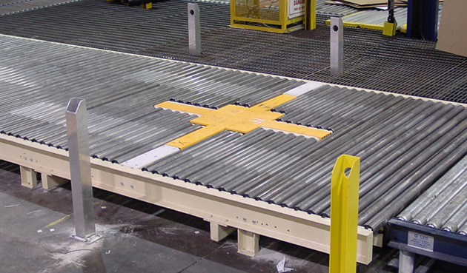

<http://www.mecatriel.com/en/Products/Handling/X-Rotating-Device>

This machine uses the X shape in the centre to turn items in rotations of 90 degrees. This is done by lifting the X shape above the belt, rotating by a multiple of 90 degrees, (90, 180, 270, 360) and lowering the X shape back down, so the belt can take the item forward. This would require a change to the top of the normal conveyor model, to include the X shape into it. However, the actual model shouldn’t rotate, just the item on it, so it can travel in another direction; this would require some changes to how the code that allows this machine to currently function.

**Concept:**

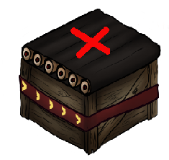

The X shape would be the main indicator of what type of conveyor this is, but only the item would rotate.

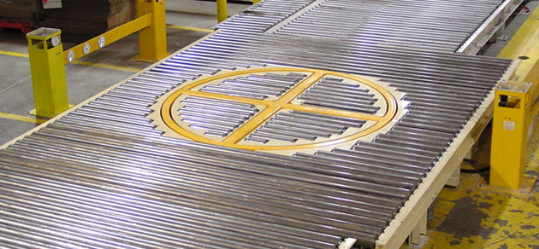

<http://www.mecatriel.com/en/Products/Handling/H-Rotating-Device>

This machine functions in the same way as the one above, only the yellow circular shape lifts up and rotates. Therefore, this would require the same changes and implementation as the one above.

**Concept:**

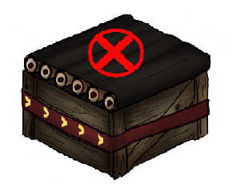

The circular, X shape would be the main indicator of what type of conveyor this is, but only the item would rotate.

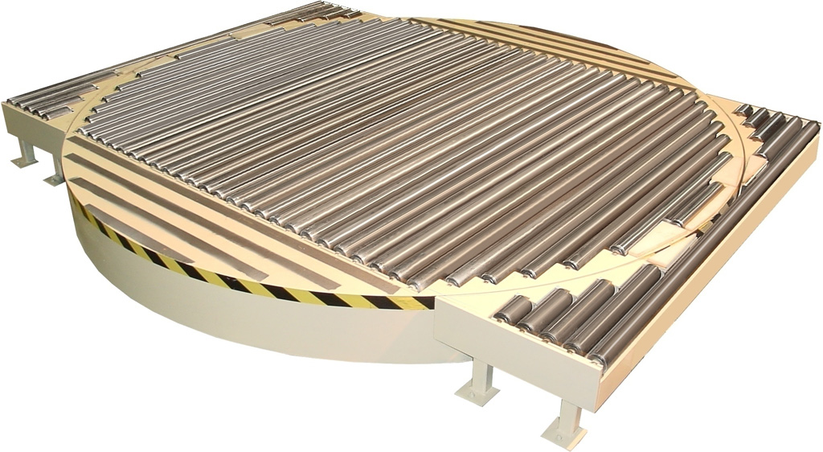

<http://www.mecatriel.com/img/Products/Handling/Rotating-Conveyor/img-3.jpg>

This is a machine that closely resembles the functionality for the rotating conveyor that we currently have in the game. The whole circular section rotates, again based on 90-degree increments. The easiest way I can see to implement this, would be to have the bottom and top of our current conveyor model separated, into 2 objects, that are placed on top of each other in game. This would allow just the top to rotate in game and would require a small amount of modelling to make. However, some way of differentiating this from a normal conveyor belt would need to be discussed, e.g. a different colour for the actual belt or the box colour can be changed, so the player can tell which conveyor type this is.

**Concept:**

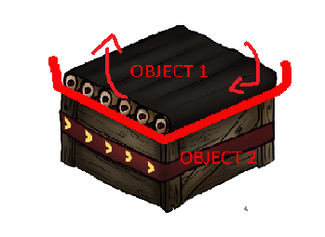Object 1 would rotate whereas object 2 wouldn’t be able to. They are separate objects hence the names. Some work would need to go into what makes this conveyor look different to the normal one.

There are other examples of real world rotating conveyors, however, they are all basically the same design, just made by different companies and with slight tweaks, e.g. smaller, taller, different colours, narrower, longer, etc.